DAISY, DAISY
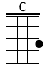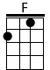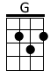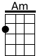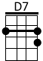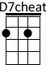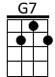
(C) Daisy, Daisy (F) give me your answer (C) do.

(G) I'm half (C) cra (Am) zy (D7) all for the love of (G) you.

It (G7) won't be a stylish (C) marriage,

I (Am) can't a (F) fford a (C) carriage.

But you'll look (G7) sweet, up (C) on the (G7) seat,

Of this (C) bicycle (G7) made for (C) two.

(C) Henry, Henry, (F) here is your answer (C) true.

(G) I'll not (C) cy (Am) cle (D7) over the world with (G) you.

If you (G7) can't afford a (C) carriage

There (Am) won’t be (F) any (C) marriage

'Cause I'll be (G7) damned if (C) I’ll be (G7) crammed,
On a (C) bicycle (G7) made for (C) two
But (C) Daisy, Daisy the (F) coppers are after (C) you

(G) If they (C) catch (Am) you, (D7) you know what they will (G) do

They’ll (G7) tie you up with (C) wire

In (Am) side a (F) Black Ma (C) ria

So ring the (G7) bell and (C) pedal like (G7) Hell

On this (C) bicycle (G7) made for (C) two!

Repeat Verse 1

Repeat the last 2 lines

